Pre-Calculus 110 Exam Review

Unit 1: Cartesian Trigonometry

**1.** Sketch an angle in standard position with each given measure.

**a)** 24° b**)** 204°

**2.** State the reference angle for each angle in standard position.

**a)** 255° b**)** 355°

**3.** Complete the table. Determine the measure of each angle in standard position given its reference angle and the quadrant in which the terminal arm lies.

|  |  |  |  |
| --- | --- | --- | --- |
|  | **Reference Angle** | **Quadrant** | **Angle in Standard Position** |
| **a)** | 30° | II |  |
| **b)** | 45° | III |  |
| **c)** | 60° | IV |  |

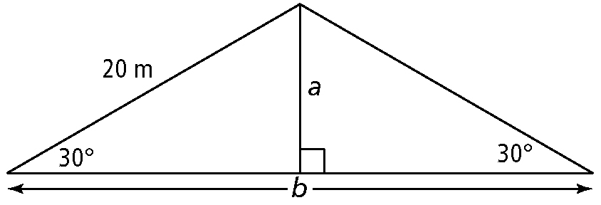

**4.** Determine the exact value of each indicated side.

**5.**  Sketch angles in standard position so that the terminal arm passes through each point.

**a)** (1, 5) **b)** (4, –3)

**6.**  Determine the exact values of the sine, cosine, and tangent ratios for each angle   
in #7.

**7.**  Determine the exact values of the sine, cosine, and tangent ratios for each angle.

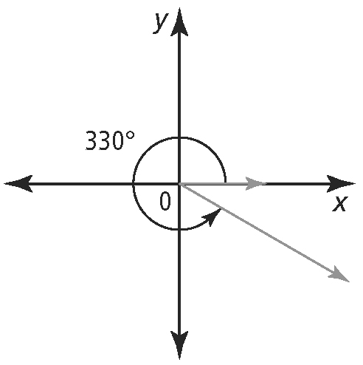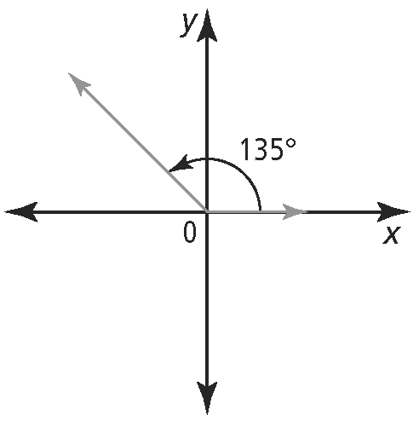**a) b)**

**8.** Without using a calculator, state whether each ratio is positive or negative.

**a)** sin 100° **b)** cos 200° **c)** tan 300° **d)** sin 350°

**9.**  An angle is in standard position with its terminal arm in the stated quadrant. Determine the exact values for the other two primary trigonometric ratios for each.

**a)** sin θ = ; quadrant III **b)** cos θ = ; quadrant IV

**10.**  Solve each equation, for 0° ≤ θ < 360°. Use a diagram involving a special right triangle.

**a)** sin θ =  **b)** tan θ =  c**)** sin θ = –1

**11.** Solve each equation, for 0° ≤ θ < 360°.

**a)** sin θ = 0.7760 b**)** tan θ = – 0.9004

Unit 2: Quadratic Functions

**1.**  **a)** Write a quadratic function in vertex form for the parabola shown on the graph.

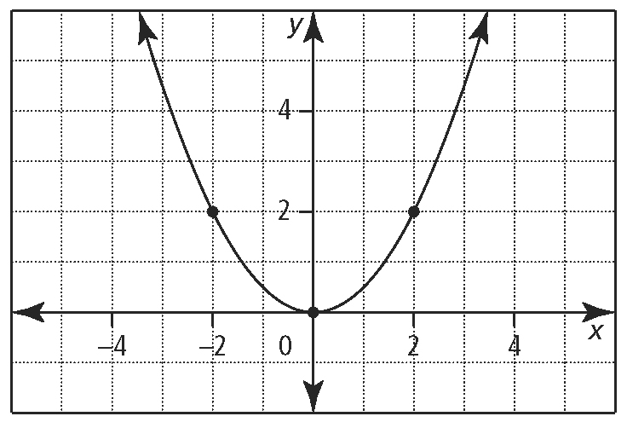

**b)** Suppose the parabola is reflected about the *x-*axis. Write the quadratic function in vertex form of the new parabola.

**c)** Suppose the parabola in the graph is translated 6 units to the left. Write the quadratic function in vertex form of the new parabola.

**d)** Suppose the parabola in the graph is translated 3 units down. Write the quadratic function in vertex form of the new parabola.

2**.** Sketch each function using transformations.

**a)** *f* (*x*) = (*x* + 7)2 – 3 **b)** *f* (*x*) = –2*x*2 + 5 **c)** *f* (*x*) = (*x* – 3)2 **d)** *f* (*x*) = 4(*x* + 2)2 – 1

**3.** Without graphing each function, identify the location of its vertex and axis of symmetry, direction of opening, maximum or minimum value, domain, range, and the number of *x*-intercepts.

**a)** *y* = 3(*x* – 5)2 + 1 **b)** *y* = (*x* + 2)2

**4.** Determine a quadratic function in vertex form that has the given characteristics.

**a)**itsvertex at (–2, 3) and passes through the point (–1, 1)

**5.** Determine a quadratic function in vertex form for the parabola.

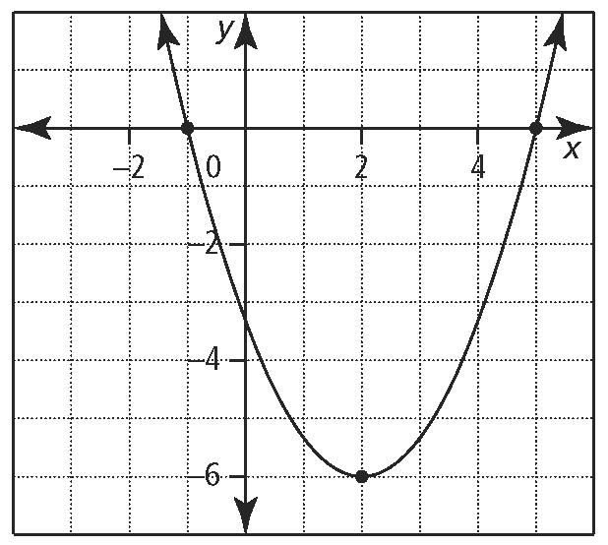

**6.**  For each graph, identify the following:

* the coordinates of the vertex
* the equation of the axis of symmetry
* the *x*-intercepts and *y*-intercept
* the direction of opening
* the maximum or minimum value
* 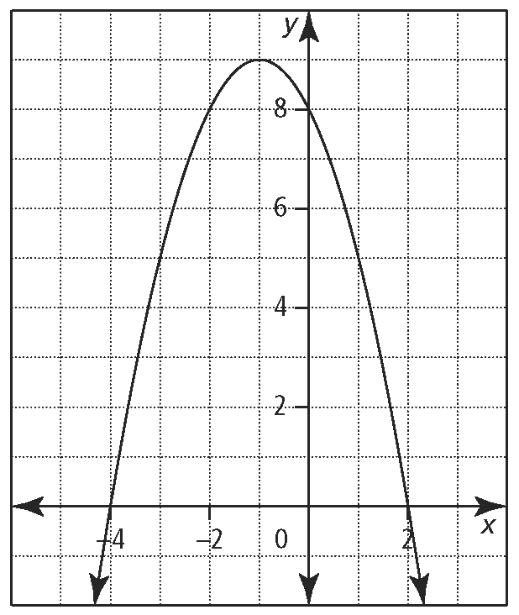the domain and range

1. 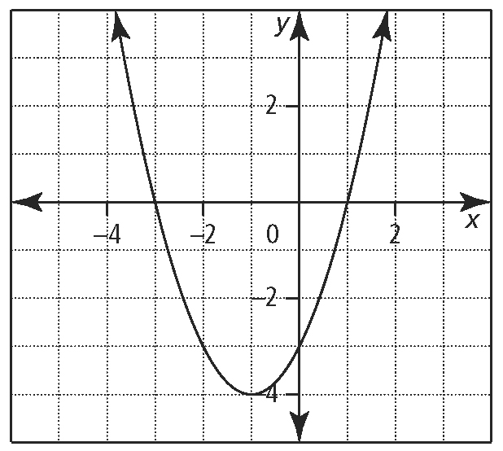**b)**

**7.**  Write each quadratic function in standard form, *y* = *ax*2 + *bx* + *c*.

**a)** *y* = (*x* + 7)2 – 10 **b)** *f* (*x*) = (2*x* + 5)(6 – 3*x*) **c)** *h*(*t*) = –9(*t* + 1)2 + 50

**8.**  A farmer has 200 m of fencing material to enclose a rectangular field adjacent to a river. No fencing is required along the river.

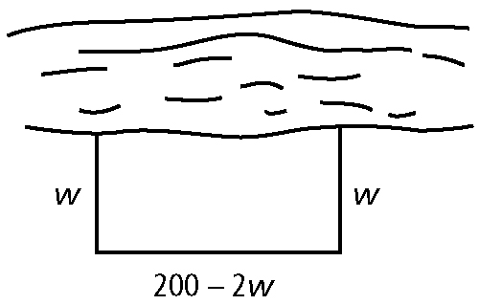

**a)** What does *w* represent in the diagram? Why is the length equal to 200 – 2*w*?

**b)** Write a function that can be used to represent the area of the field.

**c)** Sketch the graph of the function.

**d)** Determine the maximum area of the field using a graphing calculator.

**e)** Determine the dimensions of the region that give the maximum area.

**9.**  A projectile is fired out of a cannon at 105 m/s from a 100-m cliff. The function that models the height, *h*, of the trajectory in relation to time, *t*, is *h*(*t*) = –5*t*2 + 105*t* + 100.

**a)** Sketch the graph of the function on a graphing calculator.

**b)** Determine the *h-*intercept of the function. What does the *h-*intercept represent?

**c)** Determine the *t*-intercept of the function. What does the *t*-intercept represent?

**d)** Determine the maximum height of the projectile and when it occurs.

**10.**  Write each function in vertex form by completing the square. Use your answer to identify the vertex of the function.

**a)** *y* = *x*2 + 2*x* – 4 **b)** *y* = *x*2 – 6*x* + 13

**11.**  Convert each function to the form *y* = *a*(*x* – *p*)2 + *q* by completing the square.

**a)** *y* = 3*x*2 – 12*x* + 13 **b)** *y* = –2*x*2 – 20*x* – 56

**12.**  If a farmer harvests his crop today, he will have 1200 bushels worth $6 per bushel. Every week he waits, the crop yield increases by 100 bushels, but the price drops 30¢ per bushel.

**a)** Whatquadratic function can be used to model this situation?

**b)** When should the farmer harvest his crop to maximize his revenue? What is the maximum revenue?

Unit 3: Quadratic Equations

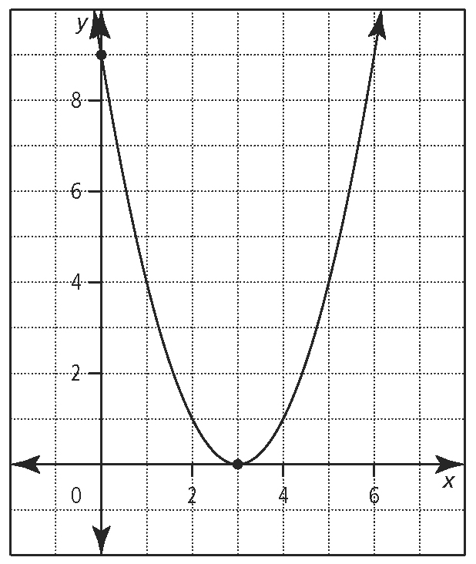**1.** How many *x*-intercepts does the graph of each quadratic function have?

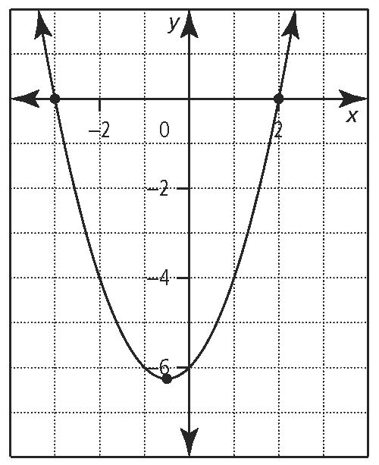**a)** **b)**

**2.**  What are the roots of the quadratic equations graphed in #1?

**3.** Solve by using a graphing calculator.

**a)** 0 = –*a*2 – 3*a* – 4 **b)** 12 = –3*b*2 – 12*b*

**4.** Determine the roots for each quadratic equation using a graphing calculator. Where integral roots cannot be found, estimate the roots to the nearest tenth.

**a)** 0 = *x*2 + 2.4*x* – 3.85 b**)** *t* 2 + *t* = –1

**5.**  For what values of *m* would the equation *x*2 + 8*x* + *m* = 0 have

**a)** one real root or two equal real roots?

**b)** two real distinct roots?

**c)** no real roots?

**6.**  An object is launched at 21.5 m/s from a height of 2.4 m. The equation for the object’s height, *h*, measured in metres, *t* seconds after launch is *h* = –4.9*t*2 + 21.5*t* + 2.4. After how many seconds will the object hit the ground? Express your answer to the nearest tenth of a second. Use a graphing calculator to solve.

**7.**  Factor.

**a)** *x*2 – *x* – 20 **b)** 3*x*2 – 30*x* + 63 **c)** – 4*x*2 – 12*x* – 8 **d)** 

**e)** 14*x*2 + 3*x* – 5 f**)** 3*x*2 + 11*x* – 20 g**)** 4*x*2 + 7*xy* + 3*y*2 h**)** 6*x*2 – 17*x* + 12

**i)** 12*x*2 – 4*xy* – 8*y*2 k**)** 140*x*2 – 450*xy* + 250*y*2 **l)** *x*2 – 49*y*2 m**)** 25*x*2 – 9

n**)**  o**)** (*x* + 1)2 – (*x* – 7)2 **p)** (*x* – 1)2 – 2(*x* – 1) – 35

q**)** 6(2*x* + 1)2 – 7(2*x* + 1) – 20 r**)** 2(7*x*)2 + 2(7*x*) – 24

**8.** Solve each quadratic equation by factoring. Verify your answer.

**a)** *x*2 – 2*x* – 15 = 0 **b)** 2*x*2 + 8*x* = 64 **c)**  **d)** 7*x*2 – 35 = 0

**9.** Determine the real roots of each quadratic equation.

**a)** 64*x*2 – 169 = 0 **b)** (*x* + 1)2 – 81 = 0

**10.**  Two numbers have a sum of 22. What are the numbers if their product is 96?

**11.**  Use the discriminant to determine the nature of the roots for each quadratic equation. Do not solve the equation.

**a)** 7*x*2 + *x* – 1 = 0 **b)** 3*x*2 – 4*x* + 5 = 0 **c)** 8*y*2 – 8*y* + 2 = 0 **d)** 3*x*2 + 6 = 0

**12.** Without graphing, determine the number of zeros for each quadratic function.

**a)** *f* (*x*) = 3*x*2 – 2*x* + 9 **b)** *g*(*x*) = 9*x*2 – 30*x* + 25 **c)** *h*(*t*) = – 4.9*t*2 – 5*t* + 50

**13.**  Use the quadratic formula to solve each quadratic equation. Express answers as exact values in simplest form.

**a)** *x*2 – 10*x* + 23 = 0 **b)** 4*x*2 – 28*x* + 46 = 0

**14.**  Use the quadratic formula to solve each quadratic equation. Express answers to the nearest hundredth.

**a)** 6*x*2 – 5*x* + 1 = 0 b**)** –3*x*2 + 5*x* + 4 = 0

**15.** For the quadratic equation 2*x*2 + *kx* – 2 = 0, one root is 2.

**a)** Determine the value of *k*.

**b)** What is the other root?

Unit 4: Radical Expressions and Equations

**1.** Express each radical as a simplified mixed radical.

**a)**  **b)**  c**)** *x* ≥ 0, *y* ≥ 0

**2.** Express each mixed radical as an equivalent entire radical.

**a)**  **b)**  **c)** *x* ≥ 0 **d)** *x* ≥ 0, *y* ≥ 0

**3.**  Simplify each expression.

**a)**  **b)** 

**4.**  Simplify each expression.

**a)**  **b)**  **c)** 

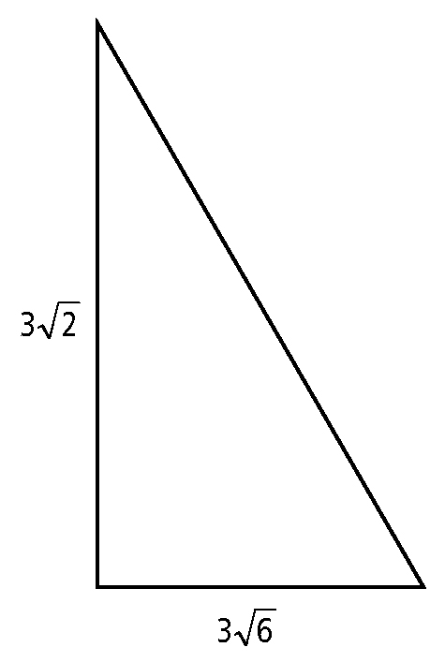d) 

**5.** What is the perimeter of the right triangle shown? State the answer as an exact value.

**6.**  Multiply. Express each answer as a mixed radical in simplest form.

**a)**  b**)**  c**)** 

**7.**  Simplify each expression.

**a)**  b**)** 

**8.**  Multiply using the distributive property. Simplify each expression.

**a)**  b**)** 

**9.**  Divide. Express each answer in simplest form.

**a)**  b**)***x* > 0

**10.**  Rationalize each denominator. Express each radical in simplest form.

**a)**   **b)** d**)** 

**d)**  e**)** 

**11.**  Solve for missing variable in each equation.

**a)**  b**)** c)

**d)**  e)  f) 

**12.**  John solves the equationHe determines two solutions: *x* = –2 and *x* = –5. Identify whether either of these values is extraneous.



.

Unit 5: Rational Expressions and Equations

**1.**  Determine the non-permissible value(s) for each rational expression.

**a)**  **b)**  **c)**  **d)** 

**2.**  Simplify each rational expression. State any non-permissible values.

**a)**  **b)**  **c)**  d**)**

**3.**  Simplify. State any non-permissible values.

**a)** **b)** c**)**



**4.** Simplify.

**a)**  b**)** 

**5.** Write each product in simplest form.

**a)** ** b) **

**6.**  Divide. Express each quotient in simplest form.

**a)** ** b) **

**7.**  What are the non-permissible values for   
the quotient  Explain your answer.

**8.**  Simplify each quotient.

**a)**  b**)** 

**9.**  State the least common denominator.

**a)**  **b)**  **c)**

**10.**  Add or subtract. Express the answers in simplest form.

**a)**  **b)** 

**11.**  Simplify.

**a)**  b**)** ** c) **

**12.**  Simplify.

**a)** **b)** c**)** 

**13.**  Solve and check each equation.

**a)**  b**)**  **c)** 

d**)**  e**)**  f**)**

**14.** John’s family travels 300 km from their home to a family reunion. His cousin Susan and her family take the same amount of time to travel 200 km from their home. Determine the speed of both vehicles given that one of the vehicles travels 30 km/h faster than the other.

.

Unit 6: Absolute Value

**1.** Evaluate each expression.

**a)** | − 4  10 | **b)** | 3  5(7) | **c)** 5( | 2 | )  | − 3 | d) 

**2.**  Given the table of values for *y*  *f* (*x*), create a table of values for *y*  | *f* (*x*)|.

|  |  |  |
| --- | --- | --- |
|  | ***x*** | ***y*** |
|  | 0 | 1 |
|  | 2 | 0 |
|  | 4 | 1 |
|  | 6 | 2 |
|  | 8 | 3 |

**3.**  Use the graph of *y*  *f* (*x*) to sketch the graph of *y*  | *f* (*x*)|.

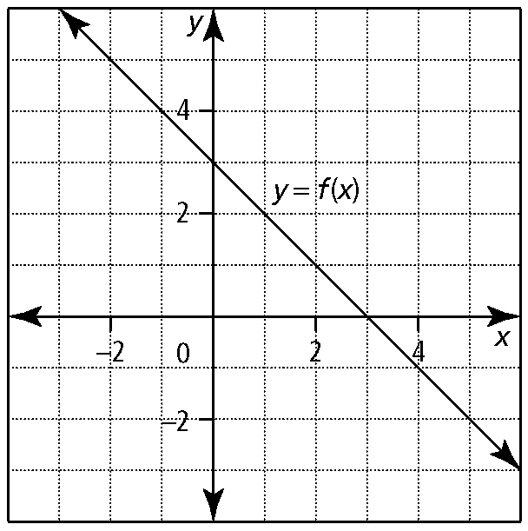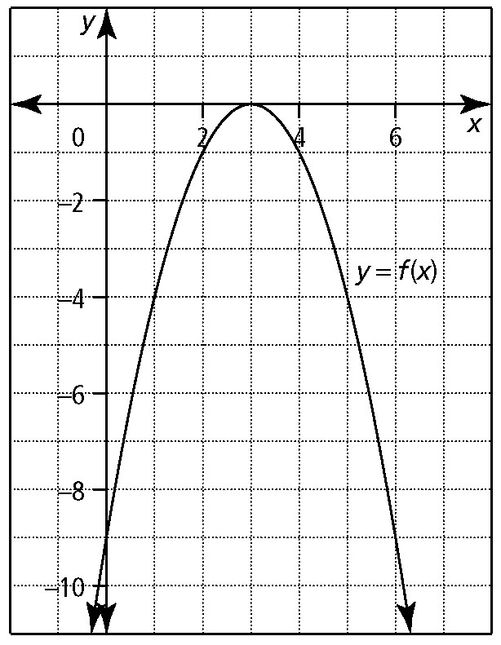**a)** **b)**

**4.**  Sketch the graph of each function. State the intercepts, and the domain and range.

a) g(*x*)  | *x*  4 | b) *y*  | *x*2  6*x*  5|

**5.**  Express each function as a piecewise function.

**a)** *y*  | 5*x*  1 | b) *y*  | 2(*x*  2)2  8 |

**6.**  Solve each absolute value equation. Verify the solution.

**a)** | *x*  1 |  2 **b)** | *x*  3 |  1  0

**7.**  Determine whether *x*  1 is a solution to each equation.

**a)** 2| *x*  5 |  8 **b)** | 3*x*  2 |  6  12 **c)** | 2*x*  3 |  5

**8.**  Solve each absolute value equation algebraically.

**a)** | *x*  5 |  3*x*  4 **b)** | 3*m*  2 |  *m* c**)** | *x*2  2*x* |  1 **d)** | 4*x* |  *x*2  5

**e)** 0  | *x*2  2*x*  3 | − 4

**9.**  Mark and Chloe each solve | *x*  12 |  *x*2. Mark solves the equation algebraically, while Chloe solves the equation graphically. Who is correct? Explain your reasoning.

*Mark’s solution:*



*Chloe’s solution:*

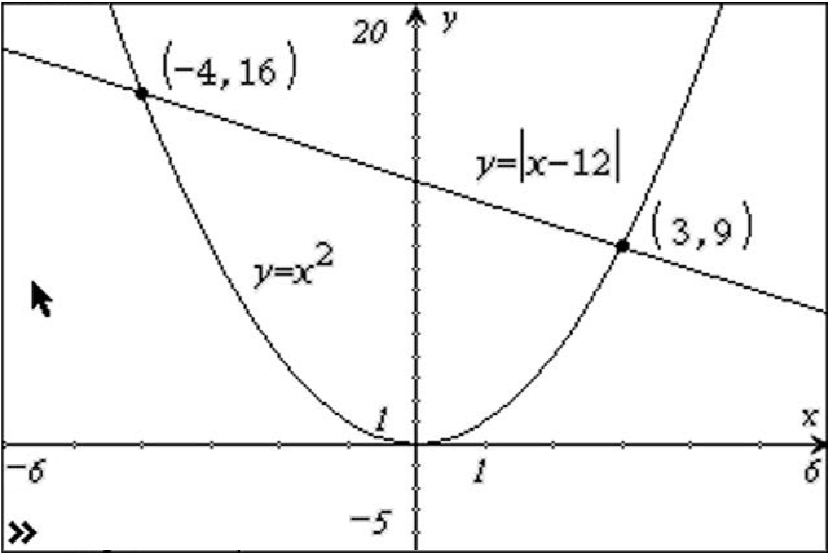

Unit 7: Systems of Equations

**1.** Verify that (1, 3) and (4, 0) are solutions to the following system of equations.

*x*2  4*x*  *y*  0

*x*  *y*  4  0

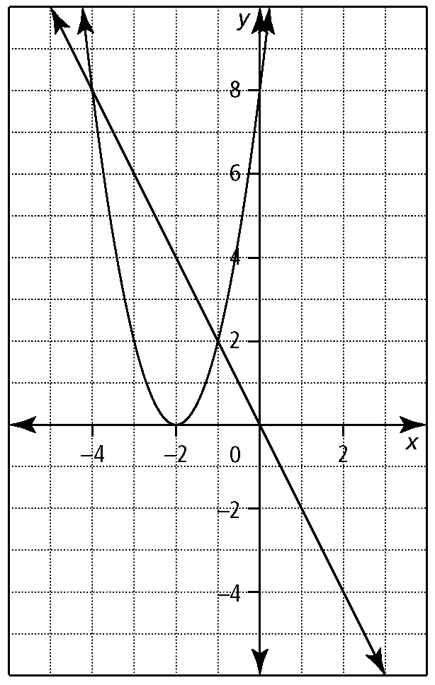**2.** Use the graph to solve the system of equations. Then, write the system of equations represented in each graph.

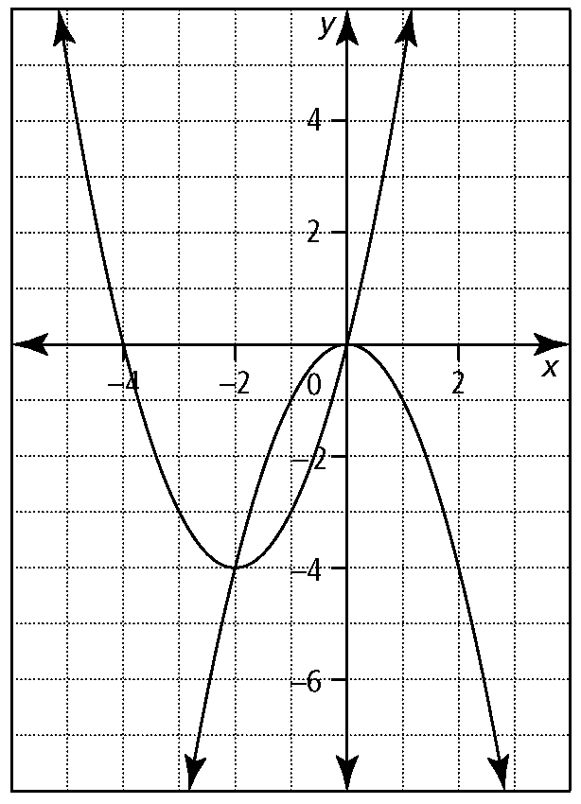**a)** **b)**

**3.** Solve each system of equations by graphing. Express answers to the nearest tenth. Verify your solutions.

**a)** *x*2  4*x*  3*y*  5

*x*  2

**b)** 0  *x*  2*y*  10

*y*  1(*x*  3)2  4

**c)** *y*  2*x*2  *x*  1

*y*  *x*2  9*x*  8

**d)** *y*  3(*x*  4)2  2

*y*  2(*x*  3)2  2

**4.** The ages of Max and his father add up to   
35 years. Max’s father’s age is the same as five more than the square of Max’s age.

**a)** Write a system of equations to represent this situation. Define your variables.

**b)** Solve the system graphically. Are all possible solutions meaningful? Explain.

**c)** How old are Max and his father?

**5.** Solve each system of equations by substitution. Verify your solutions.

**a)** *y*  2*x*  1

*y*  *x*2  5*x*  13

**b)** *y*  *x*2  3*x*  14

*y*  3*x*2  5*x*  18

**6.** Solve each system of equations by elimination.

**a)** 3*x*2  *x*  3*y*  8

*x*  3*y*  9

**b)** *y*  2*x*2  *x*  1

2*y*  2*x*2  *x*  1

**7.** Consider the following system of equations.

*x*2  6*x*  *y*  *k*  0

3*x*  *y*  *k*  0

**a)** Determine the value of *k* if a solution   
is (3, 2).

**b)** Determine the second solution.